Ontario Horticultural Association
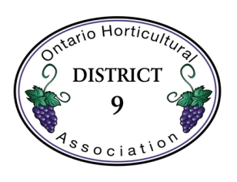
District 9

SPRING AGM 2019

Getting to Biodiversity

Saturday, April 27

Host: Grimsby Garden Club

Livingston Activity Centre
18 Livingston Ave.,
Grimsby, ON L3M 1K7

8:30 a.m. - REGISTRATION
10:00 a.m. - Judging and Meeting to begin

Tickets - Click below to order at Eventbrite:
https://www.eventbrite.com/e/ontario-horticultural-association-district-9-spring-agm-2019-tickets-56491404311
Or $20 pp at the door

Margaret Tanaszi: Director
Susan Lusted: Assistant Director
Linda Olsson: Assistant Director
Amber Cuthbertson: Assistant Director
Alan Daniels: Treasurer
Maggie Corner: Secretary
Susan Lusted: Past Director

Schedule

8:30 a.m. Registration, morning beverages and mixed goodies

10:00 a.m. Welcome: Marg Tanaszi
Sing O Canada

Greetings - Stephen Hargrave, President, Grimsby Garden Club
- Mayor of Grimsby or designate

Minutes of 2018 AGM - Maggie Corner

Roll Call of District Societies - Maggie Corner

Treasurer’s Report - Alan Daniels

Old/New Business - Marg Tanaszi

OHA Rep - Vicky Culbert, Director District 8 - OHA Greetings

Election and Installation of Executive - Vicky Culbert

11:00 a.m. Speaker: Cathy Kavassalis, Master Gardener, Oakville Horticultural Society, “Pollinator Gardens from the Ground Up”

12:15 p.m. Lunch from Fit To Eat - Browse our Draw Tables

1:15 p.m. Awards and Presentations - Sue Lusted
    - Basil Schumacher Award - best design
    - Doris Lightheart Award - highest percentage increase in membership for 2018
    - Flower Show Winners

1:30 p.m. Speaker: Sue Clarke, NPC School of Horticulture,
”The Legacy Prairie Garden at Niagara Parks Botanical Gardens”

Society Door Prizes (Linda Olsson) and supplemental Draws (Amber Cuthbertson)

3:30 p.m. Acknowledgements, adjournment and refreshments

Reminders
- Washrooms and Fire Exits
- Attendees are asked to either turn cell phones off, or to vibrate, or airplane mode. If you must answer your phone, please leave the room and proceed to the hallway.
- Each Society is to bring a Draw Prize (garden related) of an approximate value of $20-25.

Flower Show Rules

- All classes are open to all District 9 members and OHA affiliates.
- Flower show registration will begin at 8:30 a.m.
- Entries are to be in place by 9:45 a.m., ready for judging at 10:00 a.m., and remain in place until the close of the meeting.
- Wild collected plants of endangered species are strictly forbidden.
- A class may be subdivided at the discretion of the Flower Show Committee.
- The Show Committee takes all reasonable actions to ensure the safety of the exhibits and containers; District 9 and the Host Society are not responsible for loss, theft or breakage.
- Novice: for entrants who have not won a ribbon in the design section of a flower show.
- Judging will be in accordance with the Ontario Judging and Exhibiting Standards for Horticulture and Floral Design, 2003.
- In all divisions, the decision of the judge(s) is final.

DESIGN DIVISION:

- Plant material for all design classes may be from any source.
- Any type of plant material may be used, including fresh-cut flowers, branches,
decorative wood, dried or treated wood, dried flowers, fruit and foliage. No soil is
allowed in any design.
- Artificial plant material is prohibited.
- Accessories may be included in design classes but should not be the primary focus.
- One entry per class per exhibitor.

HORTICULTURAL DIVISION:

- Classes 7-10 must have been grown by the exhibitor.
- Classes 7-10 two entries per exhibitor, but must be different cultivars/species.
- Classes 11-13 one entry per exhibitor.
- Classes 11-13 entry must have been in the exhibitor’s possession for 2 months.

PHOTOGRAPHY DIVISION:

- Entries must have been taken by the exhibitor in Ontario in the past 12 months.
- Software to prepare entries, finish, colour, or other effects is the exhibitor’s choice.
- Entries are to be borderless, maximum size 5” X 7”, unless stated otherwise.
- Photos are to be mounted on card stock or construction paper. Maximum mat size 6” X 8” unless specified otherwise.
- A label with the exhibitor’s name is to be attached on the back side of the backing.
- Exhibits will be judged on the basis of the entry’s merits as a photograph (not the quality of the subject in the photograph) as follows:
  - Conforms to rules and class description
  - Composition, clarity, contrast and colour balance
  - Artistic merit

Prizes

Design: First - Gift card $15.00; Second - Gift card $10.00
Horticulture: First - Gift card $10.00; Second - Gift card $5.00
Photography: First - Gift card $10.00; Second - Gift card $5.00

Design Division

CLASS 1 “Garden Friends” – A design

CLASS 2 “ Small Things” – A Small design, not to exceed 10” in length, width & height

CLASS 3 “Spring Water” - A Water Viewing design

CLASS 4 “Think Green” – A design

CLASS 5 NOVICE - “Spring” - A bouquet of cut flowers and foliage in suitable container. (No floral foam.)

CLASS 6 NOVICE - “Recycle”- A design in a recycled item: i.e. can, foil or Styrofoam container. Floral foam and/or floral frog/Kenzan may be used.

Horticulture Division

CLASS 7 Tulip, 1 stem, any cultivar

CLASS 8 Narcissus – 1 stem, any cultivar

CLASS 9 Spring bloom – any other bulb or perennial, 1 bloom, stem or spray, named

CLASS 10 Flowering branch - not to exceed 24”, named

CLASS 11 Container-grown plant - grown for foliage, any cultivar, named

CLASS 12 Container-grown plant - in bloom, any cultivar, named

CLASS 13 Container-grown plant collection – Succulents, 3 to 5 specimens, displayed in separate containers on tray, placemat, etc.

Photography Division

Class 14 “Life in the Garden”

Class 15 “Insect Visitors”

Class 16 “For the Birds”

Class 17 “Garden Creature(s)”

Class 18 “Macro Magic” - Close-up of flora or fauna - not to exceed 7” all sides; mat can be up to 8” all sides

Class 19 “Biodiversity” - A collage of flora and fauna - created digitally or with individual photos to a size of 7” X 9” - mounted as per rules on 8” X 10” background

ABOUT OUR SPEAKERS

Cathy Kavassalis

Catherine Kavassalis is a passionate gardener and conservationist. A former chemist, she
did her doctoral work at M.I.T. and later received a master's in environmental education
from the University of Toronto. She has taught and worked with not-for-profit organizations
promoting biodiversity. Now she volunteers as an educator and inspirational speaker. She
is a member of the Halton Master Gardeners group, the Past President of Oakville Horticul-
tural Society and a former member of the Board of Directors for the Royal Botanical Gar-
dens. Catherine loves to garden and believes that caring for plants is critical for the well
being of our planet. Catherine enjoys learning and sharing knowledge, and by doing so,
endeavours to stimulate interest and awe in the living world.

Sue Clarke

Sue Clarke, NPD (Niagara Parks Diploma), is an Instructor/Curator at the Niagara Parks
School of Horticulture where she instructs courses in perennial identification, plant culture
and seasonal design. As curator, Sue oversees the perennial plant collection on the
grounds at the NPC Botanical Gardens, including the Legacy Prairie Garden there. Sue has held other teaching positions and has worked at the City of Toronto and Burlington. Sue enjoys travel and has visited many gardens in Europe and the States.

Directions

Here is a map - use postal code for GPS

Livingston Activity Centre
18 Livingston Ave.
Grimsby ON
L3M 1K7

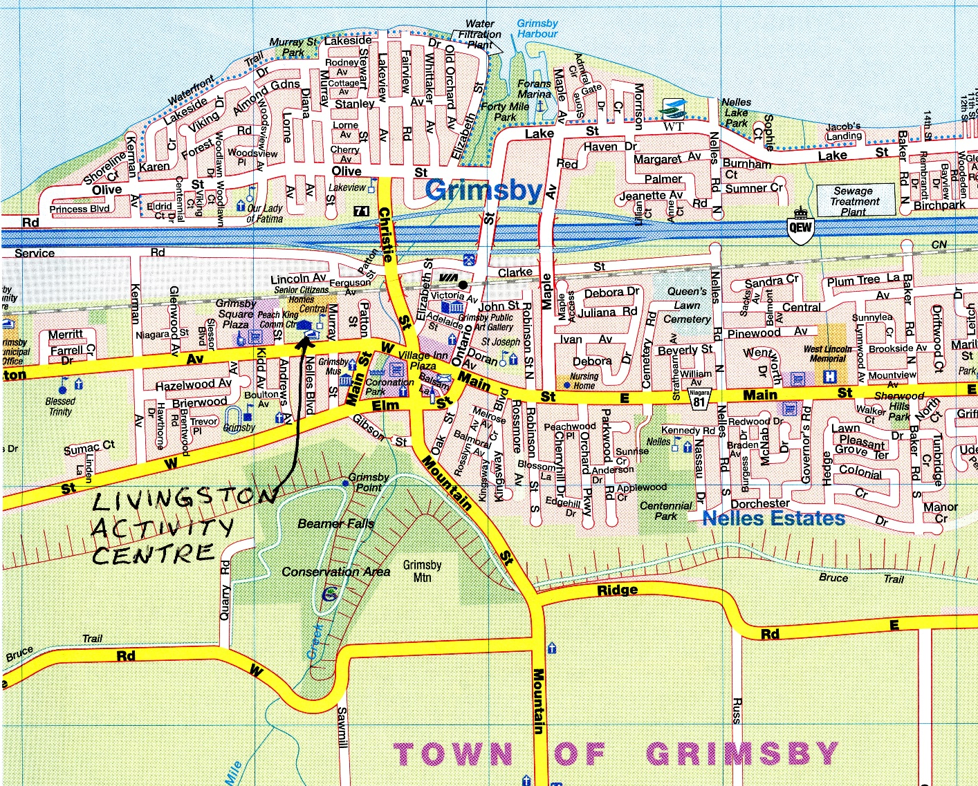

From Southeast (Port Colborne): Hwy 406 north, exit at QEW west to Toronto. Take exit 71 (Maple/Ontario/Christie). Turn left on Ontario St. Turn right on Main St. W./Regional Rd. 81. Continue (becomes Livingston Ave.). Destination is on right.

From South ( Smithville): Head northeast on Canborough St./Regional Rd. 14 toward Mill St. Slight left onto Griffin St. Turn left on West St./RR 20 west. Turn right on Grimsby Rd./Regional Rd. 12. Turn left on Main St. West/Regional Rd. 81. Continue (becomes Livingston Ave.). Destination is on right.

From East (Niagara Falls): Hwy. 420 west, exit at QEW west to Toronto. Take exit 71 (Maple/Ontario/Christie). Turn left on Ontario St. Turn right on Main St. W./Regional Rd. 81. Continue (becomes Livingston Ave.). Destination is on right.

From Southwest (Lincoln): Go south on Mountain Rd./Regional Rd. 18 toward Phillip Rd. Continue on Phillip Rd. towards Grimsby. Continue (changes to Sobie Rd.). Turn right on Thirty Rd. Continue (changes to Ridge Rd.). Turn right on Mountain St./Regional Rd. 12. Turn left on Main St./Regional Rd. 81. Continue (becomes Livingston Ave.). Destination is on right.

