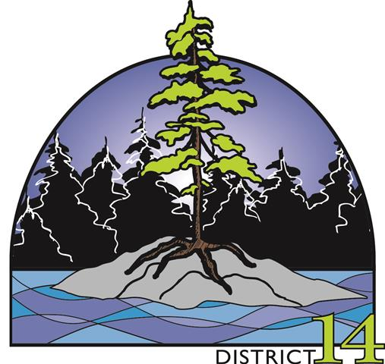

REGISTRATION FORM
District 14 Annual General Meeting
Hosted by Fort Frances Horticultural Society
May 31st and June 1st , 2019
Sister Kennedy Centre
401 Nelson Street, Fort Frances, Ontario

(Print please)
Name of Society: _____________________________________________
Name of Delegates ________________ _______________ ___________
________________ _______________ ___________
________________ _______________ ___________
________________ _______________ ___________

Society Fee …………………………………………..$40.00
Total number of delegates’ ______ X $40 ________
TOTAL $

(Cheque payable to the Fort Frances Horticultural Society)

Dietary restrictions/allergies: ______________________________________

NOTE: Please confirm your attendance by email to Judy Koski (judykoski@yahoo.ca) prior to May 4th.

Please mail your Society cheque for the Society fee and for the number of delegates attending by May 4th.

